
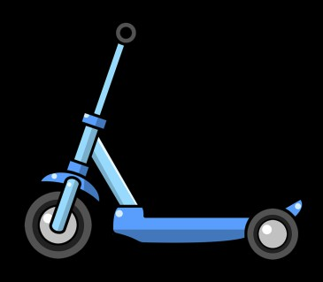

Grade 3-English
Name:________________ Date:_______
MY NEW SCOOTER

It was amazing. I couldn’t keep my eyes off of it. The way it shined in the light kept drawing my eye back to it. My dad noticed.
“Sophie, you have a scooter already, a really nice
one!”
“I know, but look at this one! It’s so shiny and new,” I said.
“It is great, but we have to get going. Come on,” said Dad.
We left the store, with me taking one last glance back at the new scooter. I
knew my scooter was nice, and it still worked even though I’d gotten it for
my birthday 3 years ago. I just couldn’t stop thinking of that new scooter!
A few weeks later, Dad and I were back in the store. The scooter wasn’t on display where it was before, but as we passed the toy section, I kept my eyes open for it. There it was, with a big sale sign on it! I couldn’t help
myself, I ran right over to it. Dad looked at the price.

“I know you’ve been thinking about this scooter a lot, Sophie, and you
haven’t asked for much from me or Mom lately. You’ve been helpful around
the house, too. The sale price is pretty good, though it’s still a lot of money.
I can’t just buy this for you, but what if I pay for part of it, then lend you the
money for the rest of the scooter, and you promise to pay me back?” Dad
asked.
“Would you really?” I said excitedly. “I promise I will pay you back, I will!”

“Sure, let’s get it,” said Dad as he picked up the box. As we were walking
toward the registers, Dad asked me if I knew what it meant to borrow
money.
“Yes, it means that I have to give it back to you,” I answered.

Dad responded, “You’re right, but you can give it back to me a little at a time. Right now you get five dollars a week for your allowance. Instead of using it for a little treat, you could pay it back to me until you pay off your part of the scooter. It will take a couple of months for you to be done paying me back for it if you do that. Does that work for you?”

“Sure, Dad! Thank you so much, I can’t wait to use my new scooter! I will pay you back with my allowance until I return all the money I’m borrowing from you today. You’re the best!”

Answer each question:

- How do you think Sophie will feel when she gives her dad her allowance
each week? Why?

- Sophie borrowed money for her new scooter. When are other times
people might borrow money?

- What does glance mean in the 5th paragraph? How do you know?

- What do you think Sophie will do with her old scooter? Why?

